Nicholas Jurgens

TIM 125

3/21/17

TIM 125 Final

**Problem 1: Planning**

1. **Define the Problem**
   1. Create a plan and time-schedule for completing the final exam. Use an appropriate table to track how well you execute your schedule and make notes on any obstacles and problems you encounter.
2. **Create a Plan**
   1. **Step 1:** Clearly state the intent of the midterm.
   2. **Step 2:** Determine the design/development sub-tasks and activities.
   3. **Step 3:** Create a design/development activity matrix purpose to understand the dependencies between the sub-task.
   4. **Step 4:** Create a schedule of tasks using a GANTT chart.
   5. **Step 5:** Identify the “critical path” for the project using PERT chart.
   6. **Step 6:** Create a table and update it with obstacles and problems that occur throughout the project.
3. **Execute**
   1. **Step 1:** The intent of the final is to gain a better understanding of material. In order to do this I need to be able to complete all nine problems in a timely manner.
   2. **Step 2:**
      1. **A:** Reading
      2. **B:** Planning
      3. **C:** SCM Design/Analysis Framework
      4. **D:** Optimal Lot Size and Cycle Inventory for Specialty Packaging Company (SPC)
      5. **E:** Safety Inventory for Polystyrene Resin at SPC
      6. **F:** Sourcing for SPC
      7. **G:** Transportation Design for SPC
      8. **H:** Execution of Your Plan
      9. **I:** Extra Credit: Project SCM Software Application
   3. **Step 3:** Activity Matrix

|  |  |  |  |  |  |  |  |  |  |
| --- | --- | --- | --- | --- | --- | --- | --- | --- | --- |
|  | **A** | **B** | **C** | **D** | **E** | **F** | **G** | **H** | **I** |
| **A** | **A** |  |  |  |  |  |  |  |  |
| **B** | **X** | **B** |  |  |  |  |  |  |  |
| **C** |  | **X** | **C** |  |  |  |  |  |  |
| **D** | **X** | **X** |  | **D** |  |  |  |  |  |
| **E** | **X** | **X** |  | **X** | **E** |  |  |  |  |
| **F** | **X** | **X** |  | **X** | **X** | **F** |  |  |  |
| **G** | **X** | **X** |  |  |  |  | **G** |  |  |
| **H** | **X** | **X** | **X** | **X** | **X** | **X** | **X** | **H** | **X** |
| **I** | **X** | **X** |  |  |  |  |  |  | **I** |

Notation:

X = “depends on”

BxA = subtasks B depends on subtask A

* 1. **Step 4:** GANTT Schedule

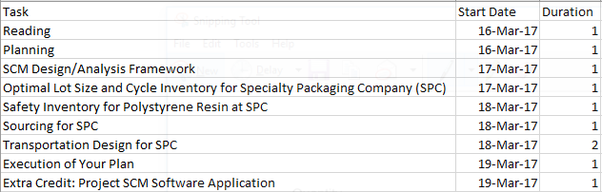

* 1. **Step 5:** PERT Chart

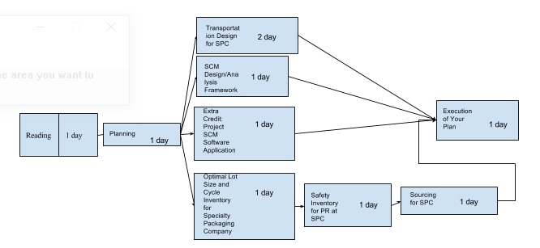

* 1. **Step 6:**

|  |  |
| --- | --- |
| **Problems that occurred** | **Solutions** |
| 3/18/17 Work took up more time than anticipated. | Add more time for problem 6 |
| 3/19/17 Couldn’t finish problem 7 due to pushing back problem 6. | Push back problem 7 |
| 3/18/17 Had difficulties with problem 6 | Read more thoroughly through chapter 13 |

1. **Draw Conclusions**
   1. My plan was to have everything done by the 19th. However, I ran into problems and had to push some of the work back. This is due to underestimating how long each problem would take. I also didn’t take into account how long I would be working for my job. Next time I make a plan I will make sure to leave more room for error. This will help reduce any risk in surprises.

**Problem 2: SCM Design/Analysis Framework**

1. **Define the Problem**
   1. You have been hired as a consultant by Plantronics, a medium-sized company “headquartered” in Santa Cruz, which is the world leader in communication head-sets. You have been asked to design their supply chain all the way from “high-level” concerns (e.g., competitive strategy, “alignment”), through analysis/procedures (e.g., inventory management models) to the actual integrated software that will be used to manage their Supply Chain.
      1. Describe the framework (process) you would use to solve supply chain management/design problems.
      2. Draw appropriate diagrams to show the structure of your frameworks and procedures.
2. **Create a Plan**
   1. **Step 1:** 
      1. Understand the customer needs
      2. Determine where the product lies in its market life cycle
      3. Determine the IDU for the product and place it on the IDU spectrum
   2. **Step 2:**
      1. For the given product establish the competitive strategy. We can do this by creating a 2x2 grid and showing what their strategy should be.
      2. Determine the trade-off between responsiveness and efficiency for the product based on the competitive strategy.
      3. Map the responsiveness/efficiency trade-off onto a responsiveness/efficiency spectrum.
   3. **Step 3:** 
      1. Create a 2-D space
         1. IDU spectrum is the x-axis
         2. Responsiveness/efficiency spectrum is the y-axis.
      2. Define a zone of strategic fit in this space.
      3. Map the SC strategy for the product in the zone of strategic fit.
   4. **Step 4:** 
      1. Create a diagram of the five SC drivers for SPC.
      2. Explain each driver.
3. **Execute**
   1. **Step 1:**
      1. Customer Needs
         1. Accurate and timely commitments
         2. Shorter lead times
         3. Flexibility
         4. Product differentiation
         5. Dedicated inventory
         6. Visibility into the supply chain
         7. High quality
         8. Automation
         9. Lowest costs
      2. Market life cycle

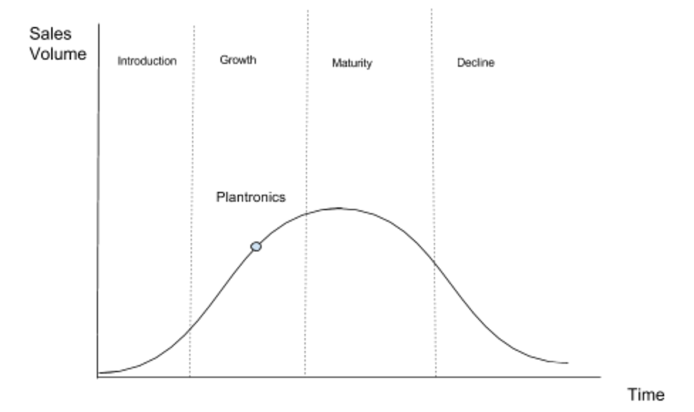

The figure above shows us the life-cycle for Plantronics. We can see that Plantronics is in the growth section of the life cycle. I placed them here because Plantronics has been around for awhile now but is continuously developing new and updated products. They are growing and now have offices in 20 different countries, including major facilities in China, England, Mexico, and the Netherlands. Being in the growth section correlates to a relatively low IDU.

* + 1. IDU spectrum

Since Plantronics is the growth part of the life cycle its IDU is relatively low. Below I place Plantronics on the IDU Spectrum.

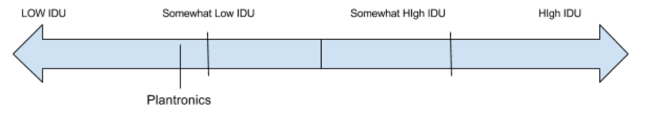

I decided to put them at somewhat low IDU due to being in the growth cycle. This is because they are growing and they know the demand they need to satisfy for their customers. Technology is also bought steadily throughout the year with spikes during the holidays.

* 1. **Step 2:**
     1. Establish the competitive strategy
        1. Plantronics focuses on cost efficiency. This can be seen in the 2010 presentation provided on the website. The below figure is taken from the presentation.

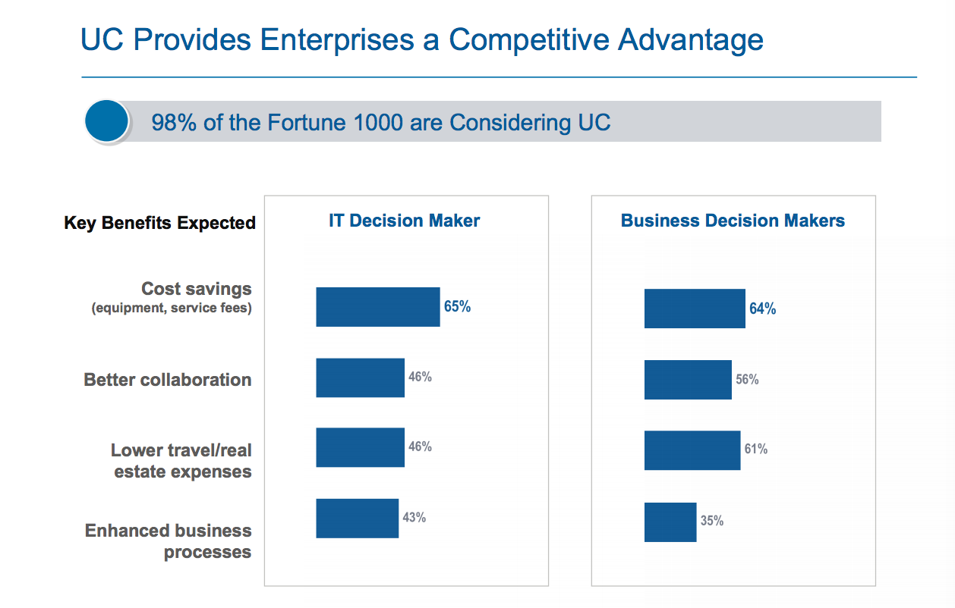

* + - 1. As you can see the cost savings is of the highest importance for the company as decided by both the IT and Business decision makers. We can show this in a 2x2 grid of “strategic target” and “source of competitive strategy”.

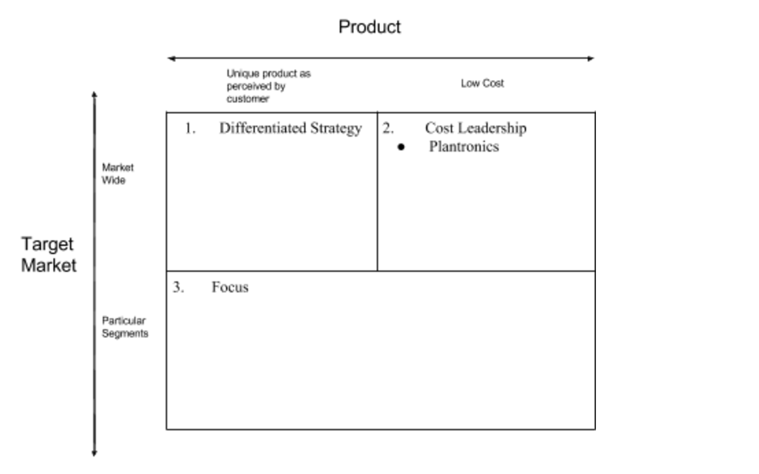

* + 1. Trade-off between responsiveness/efficiency for the product based on the competitive strategy.
       1. Plantronics is focusing on efficiency because their competitive strategy is cost leadership. They can achieve this by being efficient.
    2. Responsiveness/Efficiency Spectrum

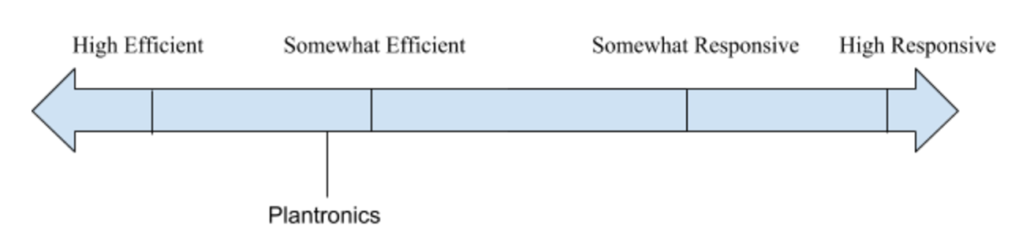

Plantronics was placed at somewhat efficient on the IDU spectrum. This is due to the fact they their competitive strategy is cost leadership. I refrained from putting them at highly efficient because they also focus on higher on-time deliveries and the ability to react to consumption changes in real time.

* 1. **Step 3:** 
     1. 2-D Space

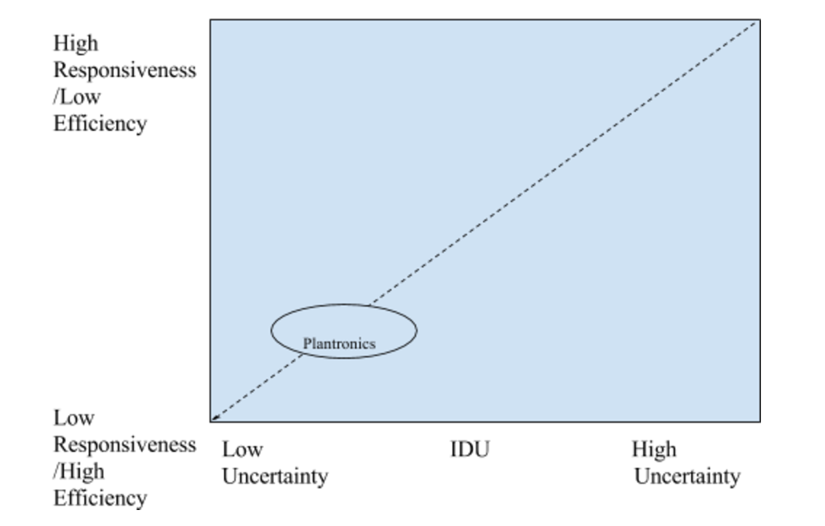

This 2-D space shows where Plantronics lies on a graph with the x-axis as the IDU and the y-axis as the responsiveness/efficiency. As we can see, Plantronics has both a somewhat low IDU and somewhat high efficiency.

* + 1. Define a zone of strategic fit.

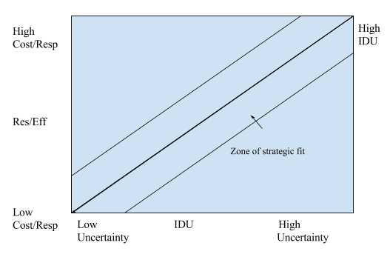

The above figure shows the zone of strategic fit. We will now show where Plantronics lies on this figure below.

* + 1. Map the SC strategy for the product in the zone of strategic fit.

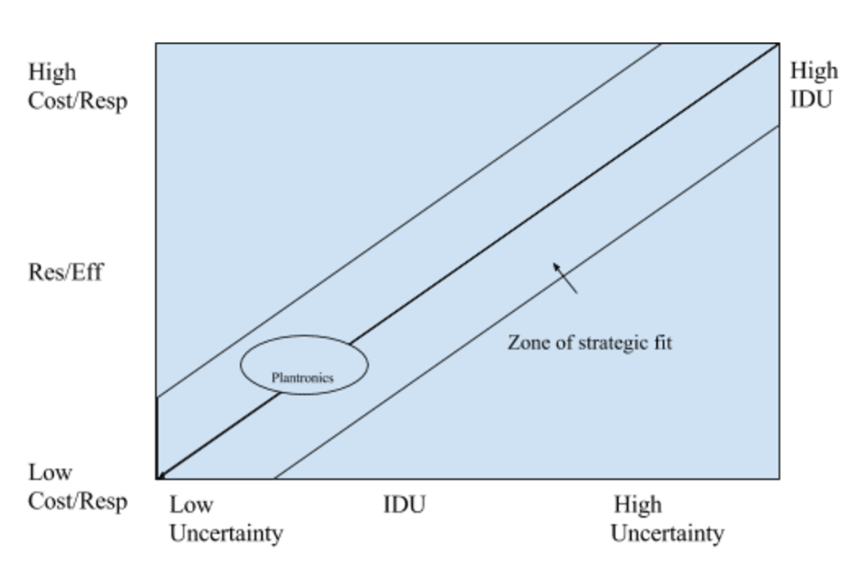

Plantronics’s optimal SC strategy is shown above. They should have a high efficiency/low and a low IDU. This is their best strategy due to them being in the growth part of their life cycle and focus on cost leadership.

* 1. **Step 4:** 
     1. 5 Driver Diagram

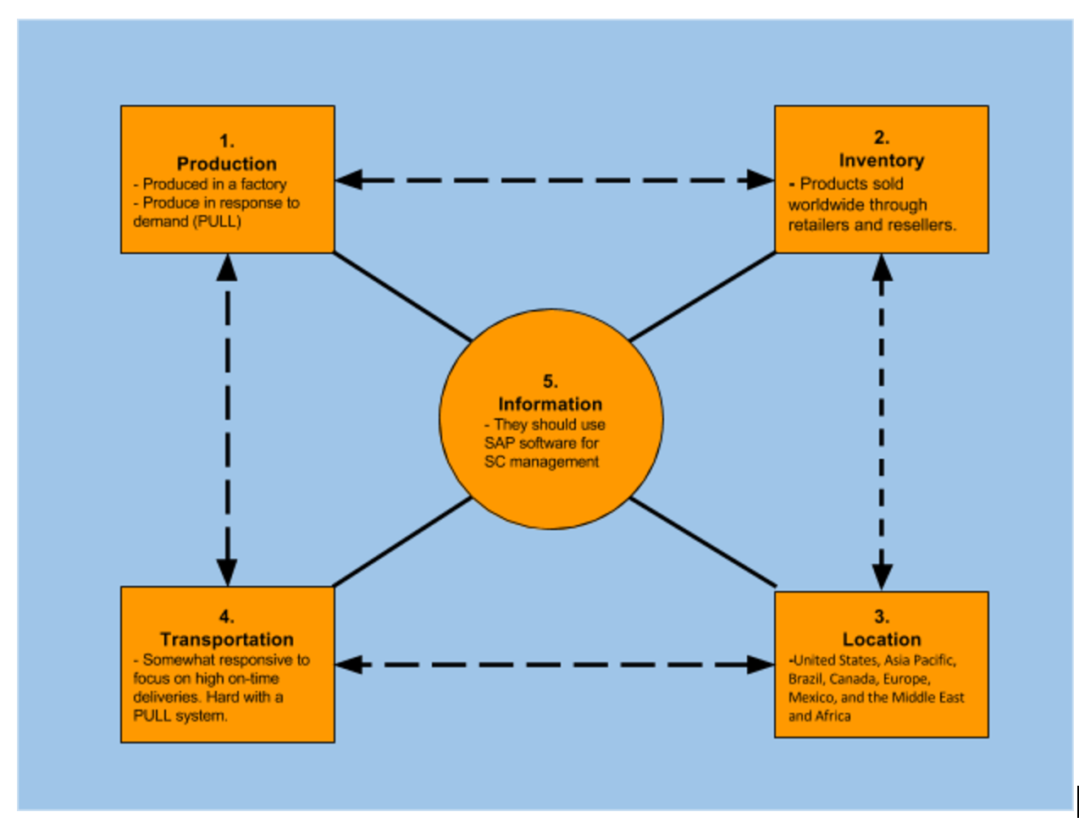

Explanation of drivers below

* + 1. Drivers explanation

|  |  |
| --- | --- |
| **SC Drivers** | **Details** |
| Production | Plantronics is using a PULL system to achieve the following: Demand driven, global, virtual supply chains, decision based, and lean practices. |
| Inventory | Plantronics products are sold and supported through worldwide network of Plantronics partners, including resellers, system integrators, retailers and mobile carriers. |
| Location | Plantronics has their locations in the United States, Asia Pacific, Brazil, Canada, Europe, Mexico, and the Middle East and Africa. |
|
| Transportation | The products and supplies will be shipped from their facilities to retailers around the world. They are responsive when it comes to transportation because they want to focus on higher on-time deliveries and the ability to react to consumption changes in real time. However, this is tough with the PULL system and their focus on being efficient. |
| Information | We will use SAP’s supply chain management software in order to maintain our shipment and orders. This is because SAP leads in terms of ERP market share and is considered one of the best supply chain management software’s. |

1. **Draw Conclusions**
   1. I used the 3-step process to create an effective SC strategy for Plantronics. This shows how they can achieve strategic fit in a SC. To do this I used the resources provided on the course website. This includes the two PowerPoint presentations on Plantronics. I Found that Plantronics struggles with the trade-off of efficiency and responsiveness since they focus on cost leadership but also having high on-time deliveries. This is why I placed them on the lower end of the zone of strategic fit with a somewhat high efficiency and low IDU.

**Problem 3: Optimal Lot Size and Cycle Inventory for Specialty Packaging**

1. **Define the Problem**
   1. If, in Problem 4 of the midterm, the holding cost h=0.15 (rather than h = 0.10), what is optimal lot size and the required cycle inventory for clear plastic? Use these new numerical values in the problems below.
2. **Create a Plan**
   1. **Step1 :** Solve for the following values for clear plastic with the new holding cost.
      1. Economic order quantity (EOQ)
      2. Cycle inventory
      3. Cycle inventory holding cost
      4. Replenishment cycle time
      5. Average flow time.
3. **Execute**
   1. **Step 1:** Values for clear plastic.
      1. Economic order quantity (EOQ)
         1. The forecasted data for 2007 using the static method is the following
         2. With the forecasted data, we can calculate the annual demand as .
         3. So with these values we have
      2. Cycle inventory
         1. The cycle inventory equation is .
         2. So
      3. Cycle inventory holding cost
         1. In our case this would be $4,142.61
      4. Replenishment cycle time
         1. We can solve for this by dividing the amount of days in a year (365) by the value we found in iii) (number of shipments per year).
         2. This would be
      5. Average flow time.
         1. .
         2. In this case we have
4. **Draw Conclusions**
   1. To solve this problem, I used information from problem 4 on the midterm. I didn’t have trouble with this problem because I already knew the equations for the values that I needed to solve for. This is because I had done it before in previous homework.

**Problem 4: Safety Inventory for Polystyrene Resin at SPC**

1. **Define the Problem**
   1. Answer the following questions about safety inventory for polystyrene resin at SPC:
      1. Why should SPC have a safety inventory? What is the average weekly demand for clear plastic (and therefore polystyrene) for 2007? If the coefficient of variation (see Fourth Edition Section 11.4: Impact of Aggregation on Safety Inventory) for clear plastic is 0.10, what is the standard deviation in the weekly demand?
      2. The Polystyrene suppliers has a lead-time of 2 weeks. SPC would like its Cycle Service Level (CSL) to be 0.90. Determine the necessary safety inventory (safety stock) level for a continuous replenishment policy. What is the Re-order Point (ROP)? What is the fill rate? What is the average inventory? What is the average flow time?
      3. Create a diagram that shows all the relevant quantities from part (b).
      4. In general, is the demand during the lead-time greater than or less than the lot size? Explain your answer using the diagram form part ©.
2. **Create a Plan**
   1. **Step 1:** Explain why SPC should have a safety inventory.
   2. **Step 2:** Solve for the average weekly demand for clear plastic.
   3. **Step 3:** Solve for the standard deviation in the weekly demand if the coefficient of variation for clear plastic is 0.10.
   4. **Step 4:** Determine the necessary safety inventory level for a continuous replenishment policy if the desired CSL is 0.90.
   5. **Step 5:** Solve for the Re-order Point.
   6. **Step 6:** Solve for the fill rate.
   7. **Step 7:** Solve for the average inventory.
   8. **Step 8:** Solve for the average flow time.
   9. **Step 9:** Create a diagram that shows all the relevant quantities from Steps 4-8
   10. **Step 10:** Determine if the demand during lead-time is greater than or less than the lot size. Use the diagram from step 9 for your answer.
3. **Execute**
   1. **Step 1:** SPC Safety Inventory
      1. SPC should have a safety inventory in case demand becomes too high for them to supply with their current lot size. A rise in unexpected demand can be countered with a sufficient safety inventory. This reduces the overall risk of losing money.
   2. **Step 2:** Average Weekly Demand for Clear Plastic
      1. From problem 2 we have that demand is . So we have
   3. **Step 3:** Standard Deviation in Weekly Demand
      1. For this problem, the equation for standard deviation in weekly demand is given by (We are given the variation as 0.10)
   4. **Step 4:** Safety Inventory with CSL 0.90 and a lead-time of 2 weeks.
      1. We can solve for the safety inventory using the following equation

First we need to solve for

We can also find that

We can now plug our values into the equation

* 1. **Step 5:** ROP value
     1. We can solve for the ROP using the following equation

First we need to solve for DL which is

Now we can plug our values into the equation and solve for ROP

* 1. **Step 6:** Fil Rate value
     1. We can solve for the fill rate using the following equation

First we need to solve for the ESC which is given by

Now we can plug our values into the equation

* 1. **Step 7:** Average Inventory
     1. We can solve for the average inventory by using the following
  2. **Step 8:** Average Flow Time
     1. We can solve for the average flow time by using the following equation
  3. **Step 9:** Diagram with relevant quantities

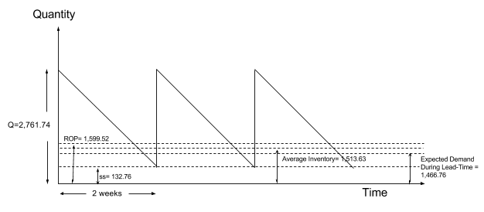

* 1. **Step 10:**
     1. The demand during the lead-time is less than the optimal lot size. As we can see the line in the diagram above I at 1,466.76 while the lot size is 2,761.74. This make sense because in order to meet demand the lot size must be greater than what is being purchased.

1. **Draw Conclusions**
   1. To solve this problem I used the values solved for in the previous problem. After solving for the values I created a diagram to compare them and give a visual representation of each one. The diagram shows that the expected demand is below the average inventory which allows the company to meet demand. The ROP is just above the average point. This is because it takes several days to place the order and receive the lot shipment. It is time so that the lot size never goes below the safety inventory. The ss is there for any unexpected spikes in demand.

**Problem 5: Sourcing for SPC**

1. **Define the Problem**
   1. Julie Williams needs to make a choice between the following 2 suppliers:
      1. Supplier 1: selling price = $10.0 per unit (1 unit = 10001b.); average lead time = 1 weeks; standard deviation of lead time = 0.5 week; Batch or lot size = 2000 units
      2. Supplier 2: selling price = $9 per unit (1 unit = 1000lb.); average lead time = 2 weeks; standard deviation of lead time = 1 week; Batch or lot size = 4000 units
   2. Answer the following questions
      1. Which supplier should Julie choose, based on minimizing total cost, if her inventory holding cost h= = 0.15 and her desired target CSL = 90%?
      2. Create a supplier scorecard that Julie can use to compare different suppliers. “Hint: Use the Utility Function approach developed in TIM-105/205 for choosing between alternatives, as well as ideas from the text.
2. **Create a Plan**
   1. **Step 0:** Read the chapters
   2. **Step 1:** Solve for the following values to calculate the total cost of each supplier
      1. Create a table with the given values
      2. Annual material cost
      3. Average cycle inventory
      4. Annual cost of holding cycle inventory
      5. Standard deviation of demand during lead time
      6. Safety inventory requires with current supplier
      7. Annual cost of holding safety inventory
      8. Annual cost of using current supplier
   3. **Step 2:** Decide which supplier Julie should choose based off of the total costs. Create a table and compare the values.
   4. **Step 3:** Create a supplier scorecard that Julie can use to compare different suppliers.
3. **Execute**
   1. **Step 1:** Total Cost of each supplier
      1. Supplier 1 Total Cost
         1. Table with given values

|  |  |
| --- | --- |
| **Variables** | **Values** |
| Cost per Unit, C | $10 |
| Lead Time, L | 1 week |
|  | 0.5 week |
| Lot size, Q | 2,000 |
| Demand, D |  |
|  | 73.34 |
| Holding Cost, h | 0.15 |
| CSL | 0.90 |

* + 1. Supplier 2 Total Cost
       1. Table with given values

|  |  |
| --- | --- |
| **Variables** | **Values** |
| Cost per Unit, C | $9 |
| Lead Time, L | 2 weeks |
|  | 1 week |
| Lot size, Q | 4,000 |
| Demand, D |  |
|  | 73.34 |
| Holding Cost, h | 0.15 |
| CSL | 0.90 |

* 1. **Step 2:** Julie should choose the first supplier since it has a lower weekly cost. Below is a table comparing all of the costs for each supplier.

|  |  |  |
| --- | --- | --- |
| Cost | Supplier 1 | Supplier 2 |
| Weekly Material Cost |  |  |
| Weekly Cost of Holding Cycle Inventory |  |  |
| Weekly Cost of Holding Safety Inventory |  |  |
| Total Weekly Cost |  |  |

Even though Supplier 2 has a lower weekly material cos their overall cost is still higher. This makes Supplier 1 the better choice.

* 1. **Step 3:** Supplier Scorecard

|  |  |  |  |  |  |
| --- | --- | --- | --- | --- | --- |
|  | Purchase Price of Component | Inventory | | Transportation Cost | Product Introduction Time |
| Cycle | Safety |
| Replenishment Lead Time |  |  |  |  |  |
| On-Time Performance |  |  |  |  |  |
| Supply Flexibility |  |  |  |  |  |
| Delivery Frequency |  |  |  |  |  |
| Supply Quality |  |  |  |  |  |
| Inbound Transport Cost |  |  |  |  |  |
| Pricing Terms |  |  |  |  |  |
| Information Coordination |  |  |  |  |  |
| Design Collaboration |  |  |  |  |  |
| Exchange Rates and Taxes |  |  |  |  |  |
| Supplier Viability |  |  |  |  |  |

Julie can use the above scorecard to rate and compare the two suppliers with different performance on each dimension.

1. **Draw Conclusions**
   1. In this problem, we solved for the values of two different suppliers and compared. Again, this wasn’t too difficult since I have made this computations in several homework’s and on the midterm. The part that gave me a little trouble was developing the scorecard. I had to read through chapter 14 in order to be able to create the scorecard.

**Problem 6: Transportation Design for SPC**

1. **Define the Problem**
   1. Create the appropriate table in Excel for comparing rail versus truck delivery options for modes of transportation.
   2. Use the table from (a) to select the optimal mode of transportation. Provide quantitative evidence to support your selection. (Use information on costs given in the case-study, and make appropriate assumptions about transportation costs).
2. **Create a Plan**
   1. **Step 0:** Read through Section 13.5 in the book.
   2. **Step 1:** Use the information from 13.5 to solve the problems.
3. **Execute**
   1. After reading section 13.5 we will be looking at two different alternatives for transportation; AM Rail and Golden. Below is a table of the given data in the section for the two different alternatives.

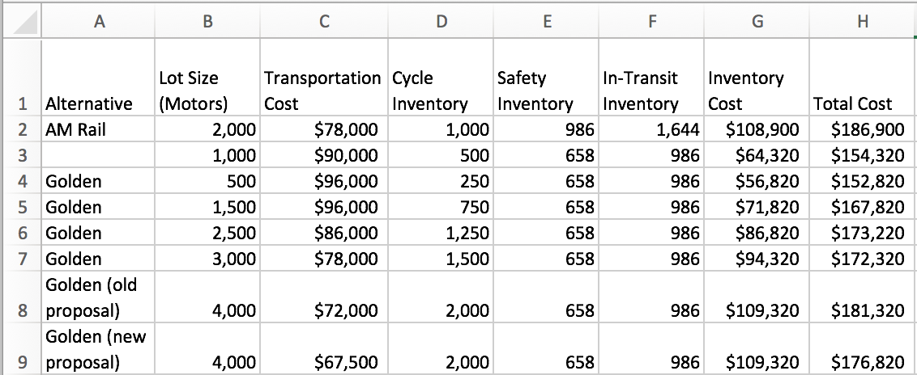

* 1. The above table shows the different costs for each option for the company EE. It looks like their best option is to use Golden at a lot size of 500. Even though this option has the highest transportation cost, it has the lowest total cost. If the selection of transportation was made using only transportation cost incurred, Golden’s new proposal would look like the best option.
  2. We can now compare the best option for Rail to the best option for Golden in the table below.

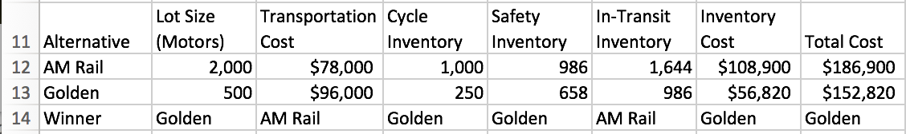

* 1. I decided to place Golden as the winner for most of the categories. The only category it lost in was transportation cost because it had a higher value. I deemed Golden the winner of Cycle Inventory and Safety Inventory because the lower these values the lower their inventory costs will be. AM Rail was the winner for in-transit inventory because by having a higher amount they can reduce the cost of transportation. This is because it reduces the amount of trips their transportation will have to make to refill their lot. Golden is the winner for the total cost and inventory cost because it has lower values. This makes Golden the best choice for the companies’ mode of transportation.

1. **Draw Conclusions**
   1. This problem may have been the most difficult for me to solve. I felt that the instructions were too vague. I read through section 13.5 and used the data that was given for the two different modes of transportation: AM Rail and Golden. I used these values to create a table and compare the different options. I then created another table to see which mode of transportation won each category. This allowed me to narrow down the best transportation mode: Golden.

**Problem 7: Execution of Your Plan**

1. **Define the Problem**
   1. Use a table to compare your plan from Problem 1 (column 1) with its execution (column 2). Indicate the reasons for the difference between the plan and its execution (column 3). Add additional columns to capture recommendations for improved execution of your plans in the future. Write down three key lessons you learned in this course.
2. **Create a Plan**
   1. **Step 1:** Create a table to satisfy the problem.
   2. **Step 2:** Write down three key lessons that you learned in this course
3. **Execute**
   1. **Step 1:** Table

|  |  |  |  |  |
| --- | --- | --- | --- | --- |
| **Problem** | **Plan** | **Execution** | **Reasons for Difference** | **What could you have done better?** |
| Reading | I planned to have this part done by 3/16/17 | I was able to finish the reading on time | No difference. |  |
| 1 | I planned to have this part done by 3/16/17 | I was able to complete it in the planned time. | No difference. | I could have been a bit more careful and reasonable with my plan. I set my end goals too early and I wasn’t able to finish them on time. |
| 2 | I planned to have this part done by 3/17/17 | I was able to complete it in the planned time. | No difference. |  |
| 3 | I planned to have this part done by 3/17/17 | I was able to complete it in the planned time. | No difference. |  |
| 4 | I planned to have this part done by 3/18/17 | I was able to complete it in the planned time. | No difference. |  |
| 5 | I planned to have this part done by 3/18/17 | I was able to complete it in the planned time. | No difference. |  |
| 6 | I planned to have this part done by 3/18/17 | I wasn’t able to finish this until 3/20/17 | I had to add more time for this problem because my job took up more time than anticipated as well as the problem itself. | I should have taken into account my work schedule and planned accordingly. |
| 7 | I planned to have this part done by 3/19/17 | I wasn’t able to finish this until 3/20/17 | I was set back by problem 6 and couldn’t finish this on the planned date. | I should have spread out the dates so problems wouldn’t have been pushed back. |
| Extra Credit | I planned to have this part done by 3/19/17 | I wasn’t able to finish this until 3/21/17 | I was set back by problem 6 and couldn’t finish this on the planned date. | I should have spread out the dates so problems wouldn’t have been pushed back. |

* 1. **Step 2:** Key Lessons
     1. I learned how to code in VBA Excel. My excel skills have increased dramatically.
     2. I learned how to compute demand forecasting using a variety of different methods.
     3. I learned how to use excel to pick the best mode of transportation and optimal facility combination.

1. **Draw Conclusions**
   1. After doing this chart I realized that not all plans will be perfect. There will be hiccups in the plan and you have to be able to adapt accordingly. This is what determines whether the end product will be good.

**Extra Credit: Project SCM Software Application**

1. **Define the Problem**
   1. Apply the SCM software developed in your group project to solve all the quantitative problems on the Midterm and Final Exams. What was your contribution to the development of the SCM software?
   2. Explain how the company from your group project could use the SCM software to manage their supply chain. You may want to start with the supply chain network (diagram) from your project to describe the information inputs and outputs for the SCM software.
   3. Develop an IT architecture (networks, databases, servers, etc.) for your SCM software to manage the information (driver) for your supply chain. How would you use this IT system to minimize the bull-whip effect?
2. **Create a Plan**
   1. **Step 1:** Apply the SCM software designed by the group to the final and provide screenshots.
   2. **Step 2:** Explain your contribution to the SCM software.
   3. **Step 3:** Explain how the company from your group project could use the SCM software to manage their supply chain.
   4. **Step 4:** Develop an IT architecture (networks, databases, servers, etc.) for your SCM software to manage the information (driver) for your supply chain
3. **Execute**
   1. **Step 1:**
   2. **Step 2:** Justin and I created the whole SCM software. We did the integration for all of the different phases.
   3. **Step 3:** Our company from the group project could use the VBA to quickly compute any needed values. We could determine the best method to compute future demand. We can also use the SCM software to determine the best combination of our plants and what our best modes of transportation are for our product.
   4. **Step 4:**
4. **Draw Conclusions**
   1. I didn’t have time to do the whole extra credit so I answered the questions I was able to. This is because of unanticipated work time.